Evonik launches pan-European distribution concept for its Household Care products
December 6, 2012

Contact person specialized press

Janna Hullmann
Communications
Consumer Specialties
Telefon +49 201 173-1410
Telefax +49 201 173-1838
janna.hullmann@evonik.com

Evonik Industries AG
Rellinghauser Strasse 1-11
45128 Essen
www.evonik.com

Executive Board
Dr. Klaus Engel, Chairman
Dr. Wolfgang Colberg,
Dr. Thomas Haeberle, Thomas Wessel,
Patrik Wohlhauser, Dr. Dahai Yu

Registered Office: Essen
Register Court: Essen Local Court
Commercial Registry B 19474
VAT ID no. DE 811160003

On January 1, 2013, Evonik will begin implementing a pan-European distribution concept in its Household Care Business Line. The strategic partner for this concept is Brenntag, the world market leader in chemical distribution.

"Brenntag is already a successful partner of Evonik in several markets. We’re convinced that we’ll be able to develop our business in Europe in a sustained manner through our cooperation with Brenntag," said Dietmar Träumer, vice president of Household Care Europe at Evonik.
"For Brenntag, Household Care supplements its existing product portfolio ideally. The cationic and amphoteric surfactants and silicone derivatives from Evonik will allow us to expand our leading position in the household care and cleaning sectors," said Dr. Thomas Heinrich, European marketing manager for Cleaning & Water Treatment at Brenntag.
Evonik's Household Care Business Line is a world leading manufacturer of raw materials and additives for the household, detergent, car care, and industrial and institutional markets. The cooperation with Brenntag covers the complete cross-application product range of Evonik's Household Care Business Line.

The product portfolio consolidates a broad range of organic and organo-silicone-based specialties to provide system solutions and tailor-made products for the needs of our customers and their markets.

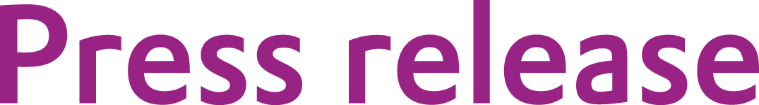

Company information

Evonik, the creative industrial group from Germany, is one of the world leaders in specialty chemicals. Profitable growth and a sustained increase in the value of the company form the heart of Evonik’s corporate strategy. Its activities focus on the key megatrends health, nutrition, resource efficiency and globalization. Evonik benefits specifically from its innovative prowess and integrated technology platforms.

Evonik is active in over 100 countries around the world. In fiscal 2011 more than 33,000 employees generated sales of around €14.5 billion and an operating profit (adjusted EBITDA) of about €2.8 billion.

Disclaimer
In so far as forecasts or expectations are expressed in this press release or where our statements concern the future, these forecasts, expectations or statements may involve known or unknown risks and uncertainties. Actual results or developments may vary, depending on changes in the operating environment. Neither Evonik Industries AG nor its group companies assume an obligation to update the forecasts, expectations or statements contained in this release.

